22.22: For points outside the sphere, the field is identical to that of a point charge of the same total magnitude located at the center of the sphere. The total charge is given by charge density volume:
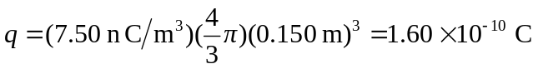
a) The field just outside the sphere is

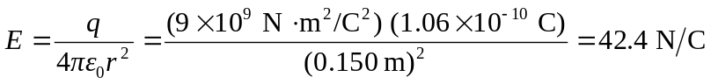

b) At a distance of 0.300 m from the center (double the sphere’s radius) the field will be 1/4 as strong: 10.6 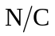
c) Inside the sphere, only the charge inside the radius in question affects the field. In this case, since the radius is half the sphere’s radius, 1/8 of the total charge contributes to the field:
